**PROJECT ON**

**SMART FARMING USING PRECISION – AGRICULTURE RECOMMENDATION SYSTEM USING ML**

**INTRODUCTION**

* India ranks second in the world in farm output but 64% of cultivated land depends on the monsoons. Irrigation accounts for nearly 85% of water and nearly 60% of water is wasted during irrigation.
* Precision agriculture can be defined as “the application of modern information technologies to provide, process, and analyze multi-source data of high spatial and temporal resolution for decision making and operations in the management of crop production.
* This Precise agriculture may give rise to enhance productivity, Soil degradation, Efficient water usage, reduction in chemical usage for cultivation, dissemination of modern farm practices to improve quality, quantity, and cost of production in crops. By incorporating Agriculture IoT solutions are focused on helping farmers close the supply-demand gap, by ensuring high yields, profitability, and protection of the environment.
* The approach of using IoT technology to ensure optimum application of resources to achieve high crop yields and reduce operational costs is called precision agriculture . IoT application in Precision Agriculture is focused on crop water management, Pest control and management, Precise detection and nutrients management and safely storing management.
* Precision agriculture also known as smart farming have emerged as an innovative tool to address current challenges in agricultural sustainability. The mechanism that drives this cutting edge technology is machine learning (ML). It gives the machine ability to learn without being explicitly programmed. ML together with IoT (Internet of Things) enabled farm machinery are key components of the next agriculture revolution.

**Why we are doing this project**

* The areas that are focused are prediction of soil parameters such as organic carbon and moisture content, crop yield prediction, disease and weed detection in crops and species detection. ML with computer vision are reviewed for the classification of a different set of crop images in order to monitor the crop quality and yield assessment.
* This approach can be integrated for enhanced livestock production by predicting fertility patterns, diagnosing eating disorders, cattle behavior based on ML models using data collected by collar sensors, etc. Intelligent irrigation which includes drip irrigation and intelligent harvesting techniques are also reviewed that reduces human labour to a great extent. This demonstrates how knowledge-based agriculture can improve the sustainable productivity and quality of the product.

**Operational Benefits**

* Today, even drones are extensively used in agriculture for research analysis, safety, rescue, terrain scanning, spatial analysis, monitoring soil hydration, identifying yield problems, etc.
* These smart drones even pinout and precisely spray pesticides on the diseased plants from the vast expanse of farmlands, help add micro and macronutrients, check physical properties such as moisture, chemical properties, pH balance by adding lime, etc.
* Precision Agriculture along with an AI-powered application facilitates in identifying the match case – tell what disease has crippled the plant and later, match it from the list of its disease imagery database, send corrective measures and so on. So, the possibilities with AI and data analytics seem endless in Precision Agriculture. The collected and analyzed data will be sent as per the farmers’ requirements and needs.

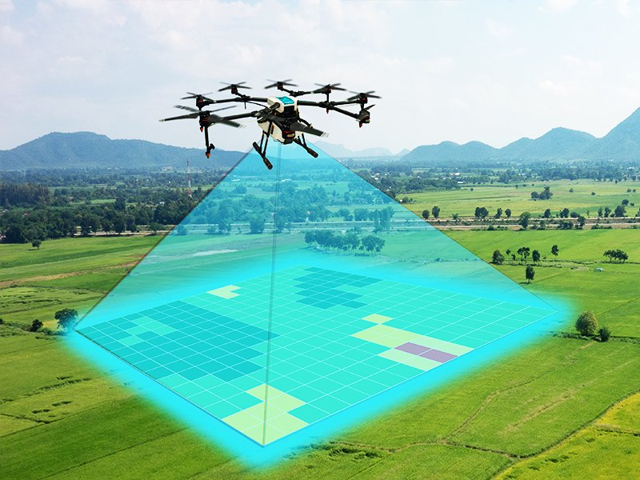

AI combined with ML, Big Data Analytics and IoT-powered smart edge devices like GPS, drones, sensors, RFID & LED lights are widely used in livestock monitoring, fish farming and smart greenhouses.